GOLDEN GATE MIDDLE SCHOOL
330 Bruce Ave. Winnipeg, MB R3J 0V8 www.sjasd.ca/school/goldengate
STUDENT-PARENT HANDBOOK
2023-24
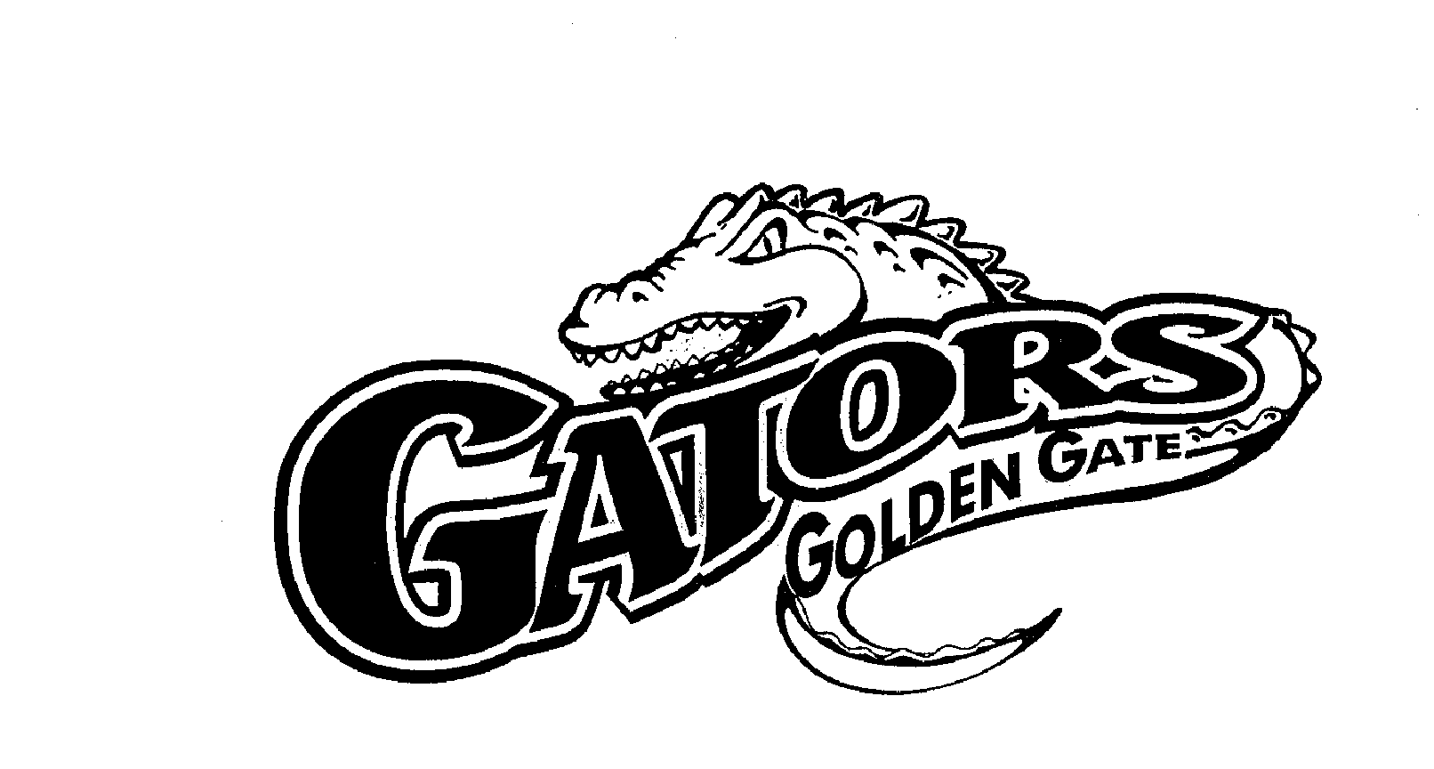
Nothing Greater Than Being a Gator!

BELL SCHEDULE
Regular School Day
8:55 | Student Entry |  | 12:40 | Student Entry
9:00 | Opening Exercises |  | 12:45 | Every Gator Reads
9:05 | Period 1 |  | 1:05 | Period 5
9:44 | Period 2 |  | 1:41 | Period 6
10:24 | Locker/ Nutrition Break |  | 2:20 | Locker/ Nutrition Break
10:28 | Period 3 |  | 2:24 | Period 7
11:07 | Period 4 |  | 3:04 | Period 8
11:45 | Students Lunch Hour |  | 3:43 | Students Dismissal
Gator Aid Mornings |  |  | Early Dismissal  1st & 3rd Tuesday of the month |  |  | Warning bell
8:55 | Student Entry |  | 12:40 | Student Entry
9:00 | Period 1 |  | 12:45 | Every Gator Reads
9:40 | Period 2 |  | 1:00 | Period 5
10:10 | Gator Aid |  | 1:30 | Period 6
10:40 | Period 3/ Nutrition Break |  | 2:00 | Period 7/ Nutrition Break
11:15 | Period 4 |  | 2:35 | Period 8
11:45 | Students Lunch Hour |  | 3:05 | Student Dismissal

Staff Meetings take place on the first Tuesday of each month. Professional Staff Meetings take place on the first Tuesday of each month.

Professional Development Meetings take place on the third Tuesday of the month except for June.

NOTE: Students are dismissed at 3:05 p.m. on these days.: Students are dismissed at 3:05 p.m. on these days

Visitors to the Office
All visitors are to report to the office upon entering the school. The necessary name tag/ identification will be distributed by the secretary, with prior approval by the principal. It is inappropriate to visit the classroom without an appointment. This policy minimizes interruptions to the learning process and maintains safety for staff and students.

Student Fees
The student fee structure at Golden Gate Middle School has been set for the 2023-24 school year as follows:
$25.00 - Student fee which would include $15.00 for Fundraising.
Students also have the option to purchase a yearbook for $25.00 (to be distributed in the fall of the following year)

Attendance
ABSENTEEISM: All student absences, lates and early dismissals must be reported by parent/legal guardian in the Safe Arrival/School Messenger system. You may also call the toll-free number at 1-844-434-8116 to report absences. Please do not call/email the school office to report absences/lates/early dismissals. For more information about Safe Arrival/School Messenger refer to the home page on our website at www.sjasd.ca/school/goldengate. Students should be aware that habitual absenteeism will hinder progress and will have a negative effect on achievement. Students who are absent are responsible to contact their peers as to missed notes, assignments, etc. Please be advised, however, that there is no infirmary at the school and if your child is ill during school hours, we will contact a parent/guardian and request that provisions be made to have him/her go home.
LATES: Students who do not arrive on time for their scheduled class will be considered “late” and will need to report to the office to get a “late slip” before they can gain admittance to the classroom. If the tardiness is without "reasonable justification" the late is recorded and late letters may be subsequently sent home, or parent called by the principal. Students are expected to arrive at school on time, but we also understand that students may be late periodically. Students are permitted one late arriving to school during a normal school week. Any subsequent lates and the student will be required to pay back the time, which depending on the reason for the late, frequency of lates, and history of lates, may range from a first offence of 15 minutes to 30 minutes. Late students will be required to pay back the time after school, completing homework or any assigned work if student is unprepared. Students who are late following lunch will be required to pay back the time after school, as they are expected to be on time following the lunch hour.
LATES BETWEEN CLASSES: Students who do not arrive on time for their scheduled classes during the school day will be considered late and consequently the teacher will deal with the incident as deemed appropriate. If the subject teacher observes a definite pattern of lates for a specific student, the teacher will communicate with the student and home. Students will be required to pay back the loss of instructional time to the subject area teacher or administration. Students will, at times, find it impossible to report to a class on time because of being detained by a teacher, office personnel or an excused absence. In such cases, the students will be given an "admit slip" to gain admittance to class without the penalty inherent in a "late slip".
EARLY DISMISSAL: Parents/guardians must report leave time in Safe Arrival. Parents must sign students out in the office just prior to leaving the building.

Start of the School Day
Students are normally not allowed to enter the school before 8:50 a.m. If students arrive early, they will have to wait outside, unless there is inclement weather.

Suspensions
Suspensions may occur for a variety of reasons, including those behaviours which are injurious to oneself and/or to others physically or emotionally. Behaviour which has a negative effect on the climate, morale, and well-being of the school and the students and staff will not be tolerated. Parents will be advised in all instances of suspension. During out-of-school suspensions, students will be forbidden access to the building and grounds and may not participate in extra-curricular activities.
A re-entry conference involving the student, the parent(s)/guardian(s) and the school may be a prerequisite for readmission after suspension. At this conference the parent (s)/guardian(s) and the student may be asked to agree to the terms and conditions of a re-entry plan. Parent(s)/guardian(s) and the student may be asked to sign this agreement in writing.

Cell Phones / Electronic Devices
Personal cell phones, camera phones, cameras and digital cameras or camcorders are not allowed for use in classrooms. Students must leave cell phones & communication devices in their lockers during the school day. They should be turned off. Students are not permitted to be taking pictures or videoing anybody while at school, this includes field trips and lunch hour. For the safety of everybody, this rule needs to be respected and followed, regardless of if you have permission of the person.
Any students not respecting these rules will have their phone confiscated by staff and be required to notify their parent. Subsequent violations will require parents to pick up the phone at the office, and students may face further disciplinary consequences. Refusal to comply will result in confiscation of devices and contact with parents for return of items. Students may face disciplinary action for insubordination. Students part of the lunch program must also have their cell phones secured in their lockers.
The school will not be responsible for loss of any electronic devices. It is strongly suggested that valuable items be left safely at home.

Students are asked to plan calls during permitted break times. It is requested that parent calls made to the office in order to contact students, be of an urgent nature only as we do not with to disturb the learning environment. Please do not use the secretaries as a message service. Your ccoperation is greatly appreciated.

ELEPHONE

Locks / Lockers
Each student will be assigned a locker by the homeroom teacher/advisor.
- Lockers must be locked at all times.
- Students must not share combinations with others.
- Lockers must be kept tidy. (There will be periodic locker inspections and clean ups.)
- Students must open their lockers when asked to do so by a staff member.
- Students will be held responsible for the care of their assigned lockers.
- Students are reminded that lockers are the property of the school. By providing a lock and locker for student use, the school does not relinquish any of its ownership rights.
- School administration may open and inspect any locker at any time.
- Students must use only school-issued locks.
Access to lockers is restricted to 8:55 a.m.- 8:58 a.m., breaks, 12:40 p.m.- 12:43 p.m. and at dismissal times. During these times, students must assemble the materials they will need until the next permitted time.

Plagiarism / Academic Dishonesty
Plagiarism is the passing off of someone else ‘s work as one‘s own. Copying directly from books or Internet sites and handing in exact copies as one ‘s own work is unacceptable and will not be tolerated. Students who plagiarize will be referred to the office and a parent, student, teacher and administrator meeting will occur due to the severity of this infraction.
The division will not tolerate academic dishonesty, which includes cheating, deception and plagiarizing. Students are expected to exhibit self-discipline, be responsible for their behaviour, and adhere to the Academic Honesty Policy.

Textbooks
Textbooks issued to students are on loan from the St. James-Assiniboia School Division and the students are responsible for the care and return of these textbooks. Students will be charged a fine if textbooks are damaged or lost. The Final Report Card will not be issued to any student who has not returned a textbook, nor paid monies for textbook misuse.

Care of School Property
Defacing of the school, littering or damaging property will not be tolerated. Students who are responsible for vandalism may be assigned community service, have to pay for repairs or replacement, be suspended and/or may have Winnipeg Police Service attend to the matter(s).

Perfumes / Colognes
Please be respectful of students and staff in the building who have allergies by not wearing or bringing sprays or scents to school. Unscented deodorant is required. We try to maintain a scent free school to accommodate those that may have respiratory difficulties and/or allergies.

Fire / Lockdown / Tornado Drills
Students are required to practice fire drills and lockdowns during the school year. These will be called at certain times by the administration. They may be called with or without warning.

Student Services - Guidance/Resource
Guidance services are available to every student. The Guidance Counselor has three functions in the school setting:
- Individual Counseling: Students can make an appointment to gain assistance with personal concerns or questions.
- Group Counseling: Throughout the year, small groups will be established to promote the development of social skills and positive people skills.
- Classroom Instruction: Students will receive presentations on a variety of topics. (Study Skills, Time Management, Transition to High School, Anti-bullying, Drugs and Alcohol, Career Exploration and Family Life.)
The main focus of the Resource program is to assist students with learning difficulties so that they may continue to progress personally, socially and educationally within the mainstream of our school. The resource teacher’s primary function is to determine the needs of those students experiencing significant learning challenges in the classroom and develop strategies to foster success for all learners. These strategies may include direct support and/or adaptations to the environment and/or adaptations to the curriculum.
Referrals for resource assistance may be made by the:
- Classroom / subject teacher
- Student
- Parent or Guardian

Active Transportation

Students using a skateboard as a mode of transportation to get to and from school must dismount the board in front of the front entrance. Skateboards must be stored in the student ‘s locker. Students are not allowed to skateboard in the front of the school or in the bus loop, before, during or after school hours. Skateboarders must dismount when approaching pedestrians. Skateboarders should wear appropriate protective gear. Upon arrival at school, students are not allowed to use on school property.
Students wearing roller blades to school must remove them at the student entrance steps. Roller blades must be stored in the student ‘s locker. Students may use scooters as a means of transportation to and from school and follow the same rules as skateboarders. Heelies are not permitted to be used or worn in the school building unless the wheels have been removed and replaced with plugs. It is a City By-Law to wear a helmet under the age of 18.
Failure to comply will result in confiscation of these items and contact with parents will result.
The school accepts NO responsibility for lost or stolen items as listed above.

Bicycles
Bicycles are permitted as they are used as a mode of transportation to and from school. The school is not responsible for any damage to or loss of bicycles and/or locks. We encourage students to lock their bikes to the racks provided. Students are not permitted to ride their bikes on school property before school, during the noon hour, or after school and must lock them upon their return to the school. They must be locked and parked in the bike rack area. Students must also wear helmets in compliance with the city by-laws.

Extra-Curricular Activities
There are many extra-curricular activities in which students can participate. Past activities include the following: Bowling, Cross Country, Curling, Volleyball, Outdoor Track, Basketball, Badminton, Rugby, Ultimate Frisbee, and Student Leadership.
When special activities sponsored by the student leadership team, are offered during regularly scheduled class time (field trips, staff/student games, etc.), students are expected to remain at school. Study time will be provided for students choosing not to participate in these activities.
Students are not excused from school attendance during these activities.

Parent Advisory Group
All parents are invited to attend the regularly scheduled Parent Advisory meetings with school staff to discuss school-related issues. There are three scheduled Parent Advisory meetings during the year, one per each term.

Lunch at Golden Gate Middle School
It is the policy of St. James Assiniboia that students should go home for lunch unless it is not possible due to distance, severe weather or physical disability.
Eating lunch at school is a privilege, not a right, and the privilege may be lost if students choosing to eat at school do not adhere to the following:
- All students staying for lunch must eat in their designated section and must have a lunch. If students do not have a lunch, they must go home for lunch.
- Students are expected to clean-up any debris left after eating their lunches.
- Refuse must be placed in the waste disposal before going outside.
- Lunch privileges will be suspended or cancelled if behaviour is inappropriate. Students must then find an alternative site for lunch, off school property. We generally follow a 3 strike rule, however, if the behavior is disruptive to the lunch program, alternate arrangements will be made.
- Lunch period is from 11:45 a.m.—12:40 p.m. No student will be permitted to leave the lunchroom area without permission of the supervisor.
- At the 12:05 lunch dismissal bell, students must prepare themselves to do one of the following by 12:10 p.m.:
-Be involved in an extra-curricular activity under the supervision of a teacher.
-Go for extra help for a specific course with the teacher that was pre- arranged
-Participate in intramural activities in the gym.
-Enjoy the outdoors.
- Students who choose to go outside will not be permitted to re-enter until school opens at 12:45 p.m.
- Hallways must be clear from 12:10 p.m. – 12:40 p.m.
Students participating in the lunch program are required to have lunch in their designated area and remain on school property during the lunch hour. Students who have parental permission to leave school property for lunch must be respectful of their behavior at all times. Students are responsible for following parent direction on whether they are allowed to leave school grounds. All students must have a parent communicate with the school that their child has permission to leave school property for lunch by note or a phone call to the office. Energy drinks are not permitted in the lunch program, or to be consumed by students on school property.
Students NOT in the lunch program must remain off of school grounds until 12:35 p.m.
There are no electronic devices/cell phones permitted in the lunch program.

Band Parent Association
Golden Gate Middle School is fortunate to have an active Band Parent Association. This group is open to all parents of Band students, and they meet on selected Wednesdays throughout the year in the Library. Band activities, performances and fundraising opportunities are discussed. Meetings are conducted by an elected committee consisting of a President, Vice President, Treasurer and Secretary. All Band parents are encouraged to attend these meetings to gain valuable insight on upcoming events.

Snowballs
Throwing of snowballs is considered a serious offence and will result in immediate disciplinary action.

Smoking/Vaping
There is a no smoking policy on school property in the St. James-Assiniboia School Division, as it is illegal. Any student caught smoking on school property, or during school time on or off school property, will be suspended. This will include the possession and/or use of a vape, which is illegal and will also be under our drug policy including paraphernalia.

Student Dress Code
It is the policy of the Division for students to dress in a manner conducive to learning. We want all students to be responsible and follow the dress code that allows all students to learn in a safe and respectful learning and teaching environment.
- There will be no hats permitted during the school day, unless students are wearing them as they immediately depart the school.
- Any clothing that is in bad taste (ie. t-shirts suggesting violence/advocating violence, offensive language, drugs) may not be worn.
- Accessories (ie. chains) and jewelry cannot be distracting or perceived as weapons. For safety reasons, accessories may not be permitted in Practical Arts or Physical Education.
The principal may make exceptions and waive aspects of the dress code during special events such as Spirit Day. Other clothing viewed as inappropriate will be at the discretion of the administrators.
Golden Gate Middle School celebrates students who meet the criteria in the following categories, by being nominated in two of these areas:
- Special Achievement
- Good Citizenship
- Volunteerism
- Involvement in Arts and/or Athletics

Great Gators Celebrations of Success
Golden Gate Middle School has four Great Gator assemblies throughout the school year to recognize student academic progress, and citizenship. During these assemblies, we acknowledge students of the month in the areas of band, choir, visual arts and athletics. We also have our Coaches Awards for recognizing participation in our co-curricular program. Parents/ guardians of students receiving awards at our Great Gators assemblies will receive teacher notification.

Mark Weighting for Report Cards
Term weighting: All marks will be calculated cumulatively. i.e. a running total of all marks will be kept throughout the year. Practical Arts is the exception with a different grade being assigned per term i.e. one for Home Ec, one for Computer Technology and one for Woods.

Student Evaluation
Students will be evaluated on their day-to-day work in a process of continuous assessment and evaluation. Students will do their best to consider that – everything is important!
Formal student report cards will be issued three times during the school year- in December, April and June. Parents are encouraged to monitor the progress of their children and to contact teachers when there is a need. All teachers are accessible by email. Parents and students have access to their parent/student portal online to monitor their progress and check for attendance.
Student-Led Conferences will be held twice during the school year during the fall and winter.

Risk Threat Assessment
The St. James-Assiniboia School Division believes that participating in and contributing to a safe, respectful and positive learning environment is both the right and responsibility of children and youth, their parents/caregivers, school personnel and all community members. A protocol has been developed for responding to student threats/high risk behaviours. (Assessing Violence Potential: Protocol for Dealing with Student Threats and High-Risk Behaviours JICM-R) A threat can be defined as follows:
An expression of intent to do harm or act out violently against someone or something. A threat can be spoken, written or symbolic; for example, motioning with one’s hand as though shooting at another person.

CODE OF CONDUCT
In alignment with the Manitoba Education Provincial Code of Conduct and the St. James-Assiniboia School Division’s Student Conduct policy (JK), Golden Gate Middle
School’s goal is to provide a safe, secure and caring learning environment, which fosters students’ personal growth, self-respect, and a sense of belonging which encourages them to be responsible citizens in the present and in the future.
Golden Gate Middle School recognizes that disciplinary measures may be necessary when other approaches to challenging behaviour have not been successful. In these situations, interventions and disciplinary consequences may have to be implemented. Interventions and consequences are consistent with the Provincial Code of Conduct and take into consideration the frequency, severity of the unacceptable behaviour and the student’s age and stage of development. Reasonable accommodations for students who have exceptional learning needs are considered. These accommodations take into account the student’s ability to comply, and the amount of support required.
Provincial Regulation: Appropriate Disciplinary Consequences in Schools states that the principal has disciplinary authority
- over the conduct of students while they are at school
- over students in terms of their conduct towards one another on their way to and from school, and while being transported via school bus
- to ensure appropriate use of social media and to address unacceptable student conduct including bullying, cyber bullying and abuse of a student by another
- to determine which consequence is appropriate in a given situation
Principals will administer such discipline as might be exercised by a kind, firm and judicious parent. Discipline is administered with dignity and professional judgment in order to promote and maintain student self-respect, self- discipline and holds students accountable for unacceptable behaviour. Working to develop a safe and positive school climate is a shared responsibility that involves cooperation between the school and parents. Golden Gate Middle School will notify parents/guardians of situations involving their child in disciplinary situations. Parents are encouraged to contact the school any time they have a concern regarding a disciplinary matter.
Students/parents/guardians may choose to follow the appeal process. This involves an appeal to the staff member who made the disciplinary decision, then to the school principal if not resolved, then to the superintendent of schools if not resolved, and finally to the Board of Trustees. In cases of suspensions in excess of five days and expulsions, the appeal goes directly to the Board of Trustees.
The content of this Code of Conduct is reflective of the following sources:
- St. James-Assiniboia School Division Policy JK
- Manitoba Education: Safe and Caring Schools Provincial Code of Conduct – Appropriate Interventions and Disciplinary Consequences
As stated within the Provincial Code of Conduct, our code of conduct will be reviewed _{st} by October 31 annually with our parent community to ensure our actions are consistent with the needs of our community.
Expanded topics related to student behaviour and conduct can be found in the Policy Manual of the St. James-Assiniboia School Division website:
www.sjasd.ca
All people on school property and/or engaged in school business must behave in a respectful manner and comply with the code of conduct.
Unacceptable behaviours include, but are not limited to, the following:
- Bullying/cyber-bullying
- Social, physical, sexual, psychological, verbal or written abuse or aggression
- Harassment/discrimination
- Under the influence or in the possession of tobacco, drugs or alcohol
- Threats to self and others
- Gang involvement
- Possession of a weapon
- Possession or being under the influence of an illicit drug/smoking/vaping • Inappropriate use of the internet and electronic devices/ communication
- Clothing and accessories deemed inappropriate for school.
- Inappropriate use of skateboards, scooters or roller blades.
- Bystander influence encouraging/supporting behavior.
- Insubordination/disrespectful behavior.
- Vandalism/defacing student work or school property.
- Inappropriate language/swearing.
At Golden Gate Middle School, we believe that mistakes are opportunities to learn and our goal is to assist children to become the people they want to be. Learning is a growth process for everyone involved, adults as well as children. We create the conditions for children to lift themselves out of failure and to leave behind blame and denial. A successful outcome allows a child to return to the group feeling strengthened.
Interventions and consequences may be applied as appropriate to the context, but they need not be applied in the order they appear in this document:
- Informal Discussion
- Parental Involvement
- School Counsellor/Resource Teacher
- Formal Interview
- Withdrawal from Classroom Setting
- Removal of Privileges
- Detention
- Compensation for Damages
- Behavioural/Performance Contract
- Student Services Involvement
- Outside Agency/Community Involvement
- Violence/Risk/Threat Assessment
- Police Notification
- Student Suspension
- Student Expulsion
Students and staff at Golden Gate Middle School have the following RIGHTS and RESPONSIBILITIES.
I have a right to be respected
and a responsibility to treat others with respect.
I have a right to be myself
and a responsibility to accept others' differences.
I have a right to learn
and a responsibility to come to class prepared.
I have a right to be heard
and a responsibility to listen to others.
Athletic Activity
Calendar 20
23-24

Proposed
Activities

Sept Oct Nov Dec Jan Feb Mar Apr May June

Cross Country
Volleyball
Basketball
Badminton
Outdoor Track
Curling
Bowling
Ultimate
Flag Football
GOLDEN GATE MIDDLE SCHOOL’S VISION
By Collaborating with parents and community in a bilingual setting, we empower students to develop their personal road to success while fostering accountability, integrity, and self-
The mission of Golden Gate Middle School is to provide a safe, nurturing and cooperative environment which will guide and encourage each individual:
 | to develop mind and body to full potential;
 | to foster respect for self, school, home and community;
 | to value learning;
 | to develop responsibility;
 | to enjoy and take pride in belonging, achieving, and caring.
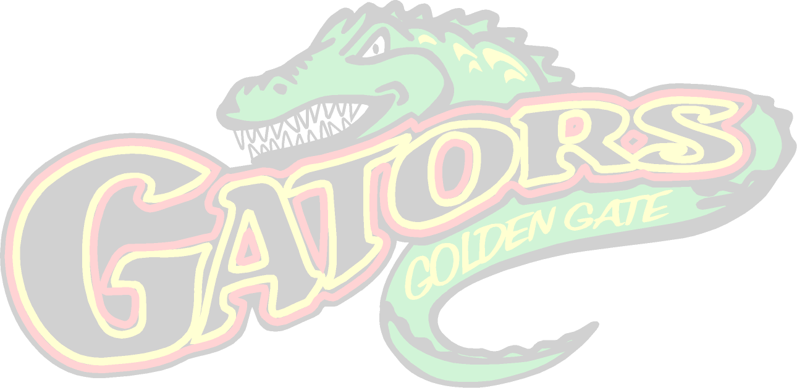
GATOR AID
TEACHER ADIVSORY PROGRAM

This time includes team building activities, such as board games and Talking Circles.
-

At Golden Gate Middle School we believe in
RESPECT _{and} RESPONSIBILITY.
RESPECT
Looks like / sounds like | Does not look like / sound like
- Listening  - Raising hand to speak  - Sharing  - Eye contact  - Participating  - Nodding  - Please/Thank you  - Working together  - Cooperating | - Talking out of turn  - Interrupting  - Sarcasm  - Eye rolling  - Silent treatment, excluding  - Yelling  - Name calling, teasing  - Hitting/kicking  - Intimidation
RESPONSIBILITY
Looks like / sounds like | Does not look like / sound like
- Being prepared  - Being prompt  - Homework done  - Being in class  - Getting caught up on missing work  - Getting enough sleep  - Eating breakfast/lunch  - Taking time for your needs | - Forgetting supplies  - Being late  - Incomplete homework  - Blaming others  - Making excuses/whining  - Arguing
RESTITUTION
www.realrestitution.com
At Golden Gate we believe in restitution. Restitution is based on the principle that all behaviour is purposeful. This means, that every behaviour meets a basic need.
The five basic needs are…
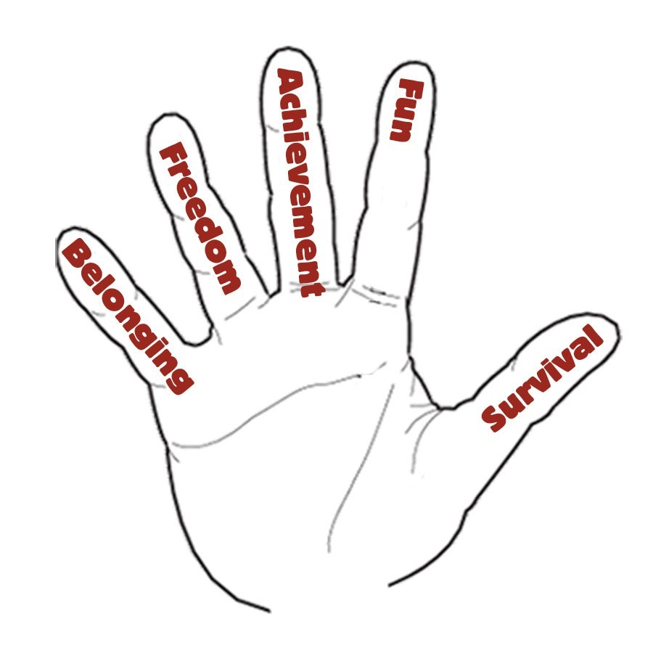
Survival:
I survive when I have enough to eat, I get a good sleep and I have clothes to wear. I feel safe when I believe that there are adults that take care of me. I feel safe when no one hurts me.
Fun:
I need to have fun. I feel like I am having fun when I am doing something that I like to do. I can have fun when I play, when I learn and when I do my work.
Achievement:
I need to achieve. I feel proud when I feel important and when I am good at something.
Freedom:
I need to have freedom. I feel like I have freedom when I have choices. I feel free when I can choose what I want to do, how I want to do it and when I want to do it.
Belonging:
I need to belong. I feel like I belong when I am a part of a group and I have friends.
It is my RESPONSIBILITY to respond to my needs in a
SAFE and RESPECTFUL manner. My BEHAVIOUR _{is expected to be} ABOVE THE LINE.
If it falls below the line, I am RESPONSIBLE to create and
follow through on a FIX IT PLAN.
ABOVE THE LINE BEHAVIOURS
CONSEQUENCES
- Positive School Culture
- Better Learning Environment
- Safer School
- Better School Community
- Being Respectful
- Being Responsible
- Being Honest
- Being Helpful
- Being Hardworking
- Being Safe
- Being Encouraging
- Being Dressed Appropriately
- Being Co-operative
- Being Prepared

BELOW THE LINE BEHAVIOURS
CONSEQUENCES
- Fix It Plan
- Teacher Intervention
- Being disrespectful (putdowns, shouting, arguing, name calling, bad language)
- Dishonesty
- Being Impolite
- Being Rude (blurting out, ignoring adults, interrupting, teasing, cutting in line)
- Being Selfish
- Being Irresponsible (ignoring the rules, not doing your best)
- Being Uncooperative
- Being Negative
- Being Unsafe (pushing, shoving, tripping, roughhousing)
- Plagiarism
ADMINISTRATIVE CONSEQUENCES
- Phone call home
- Community Service
- Detention
- Suspension
- Suspension
BOTTOM LINE BEHAVIOURS
- Disrespecting Self, Others, Property
- Direct defiance/Swearing
- Bullying/Harassment
- Violence/Threats (physical and verbal)
- Drugs/Alcohol
- Vaping
- Cell phones in class
- Vaping
Based on the principles of restitution (www.realrestitution.com)

