Bruce Leadership Team Taco Tuesday
Lunch

November 28th, 2017
Cost: 5.00 please send exact amount only, if you are doing a cheque please make payable to Bruce Middle School
Includes: Taco in a Bag-Doritos bag, lettuce, ground beef, cheese and a can drink or water bottle
Optional toppings salsa and sour cream
All orders must be in by Monday November 28th, 2017
No late orders please
Please fill out the bottom portion of this form and return to your Blast teacher with your money

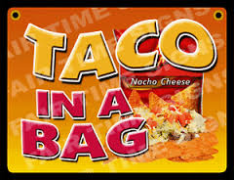

----------------------------------------------------------------------------------------------------------------------------

Student Name: _______________________

Blast: ________________________

I would like to order #______taco lunches with drink cost-$5.00 each

I would like to order: #______ additional taco bag cost-$4.00

Total amount enclosed: ________

