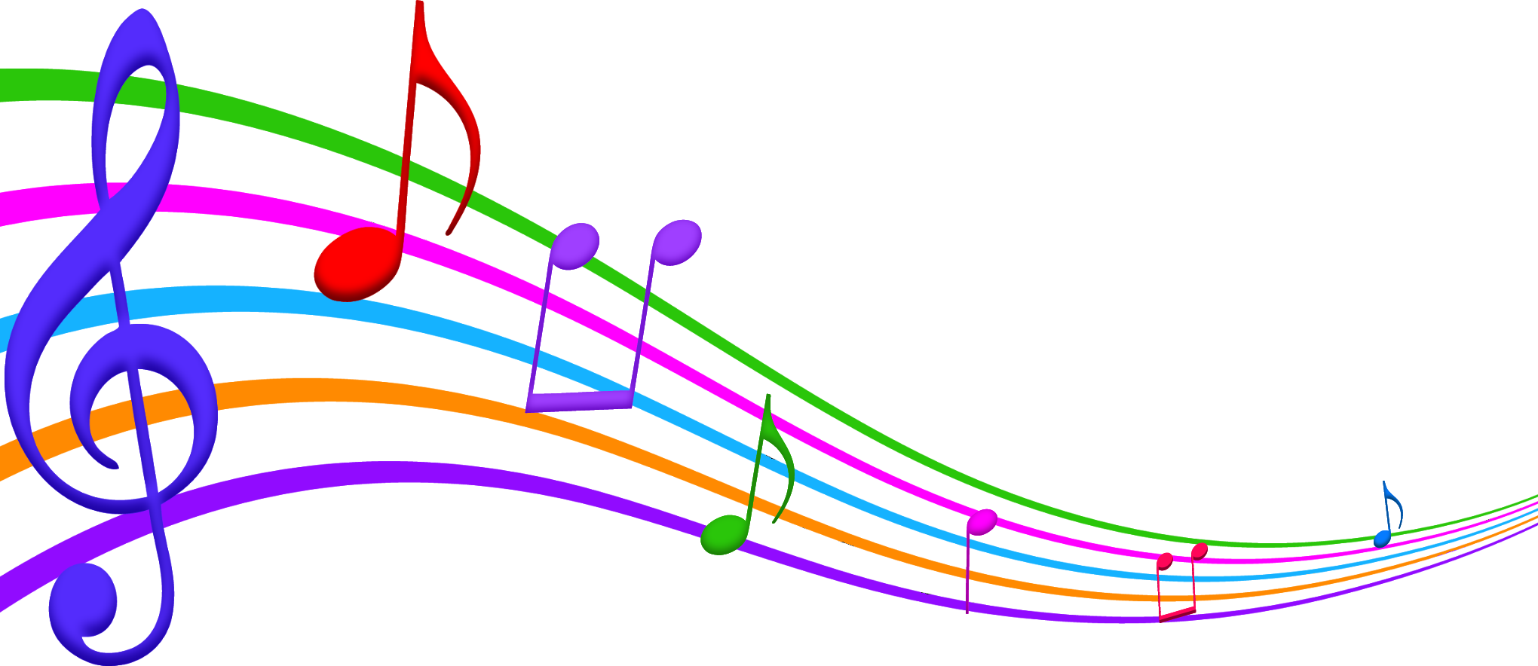
The 2022-2023 school band season is well underway, and we are excited to bring you another fundraiser. As always, all funds generated from the fundraiser will be dedicated to helping deserving students attend summer band camp this year! We’d love to be able to help as many students as possible this summer!
The Band Parent Association is excited to partner with Archie’s Pizza, just in time to stock the freezers for quick meals over Spring Break!
Archie’s Pizza is made with Bothwell cheese and their meats are processed at Archie’s Meat Market in Starbuck, Manitoba. How awesome is it to support a local business while supporting our band students!
$4.00 from every pizza sold will directly back to our Association, with all funds going towards the 2023 summer band camp!
Payment Options:
- Families submit the total sum of their orders via cheque (payable to Golden Gate Band Parent Association) or e-transfer (payable to goldengatebandparents@gmail.com). No cash, please.
- Forms with attached cheques can be deposited into the secure band fundraiser box in the Golden Gate band room.
Important dates:
- Order forms with payment are due no later than Wednesday March 8, 2023. Please note that late orders will NOT be permitted.
- Pizzas will be delivered and ready for pick up at the school Wednesday March 22 2023 between 4 pm – 5 pm in the Golden Gate band room.
Thank you in advance for your support of our band students!
Sincerely,
Golden Gate Band Parents Association

