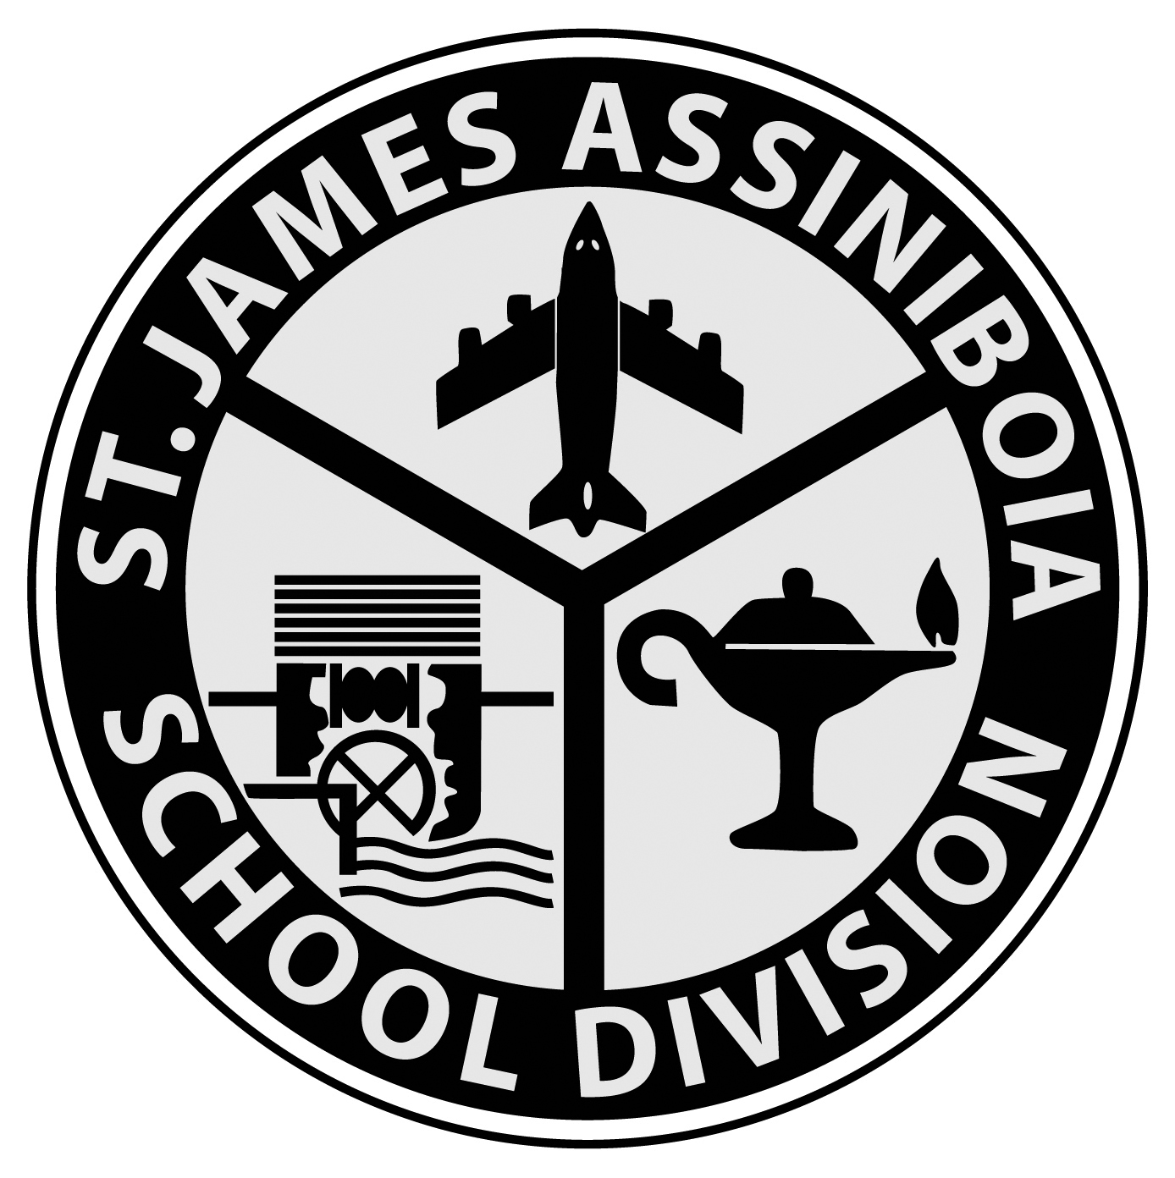
Lincoln Middle School
3180 McBey Avenue
Winnipeg, Manitoba
R3K 0T7
Phone: 204-837-8397 Fax: 204-885-3368
Website : www.sjasd.ca/school/lincoln Email : lincoln@sjasd.ca

STUDENT REGISTRATION 2020-21
NOTICE: This registration form is to be completed by the parent/guardian. Providing false, misleading or incomplete information in this application will constitute just cause for possible withdrawal from school.

File Requested:_________________

Date Received__________________
Great Schools for Growing and Learning

REGISTRATION INFORMATION
You are enrolling your child in Grade: 7
Previous School Attended: ________________________ Previous Grade: _____6_____

STUDENT INFORMATION
LEGAL NAME: ____________________________/______________________________/________________________

(On Birth Certificate) Last Name First Name Middle Name
I agree to provide a birth certificate for the child (if not previously submitted), a Manitoba Health card for the child and two official documents with the current address of the legal guardian(s).

Preferred First Name: _________________________________________ Birth Date: (m/d/y): __________________
Legal Gender: __________________ Preferred Gender: Trans Person Two Spirit Gender Non-Conforming

Home Phone Number: _______________________ Student Cell Number (if applicable): _______________________

Mailing Address: ___________________________________/__________________/__________/__________________

Street/Apt # City Province Postal Code

Manitoba Education (MET) #: __________________ Student Social Insurance Number: _______________________

FAMILY INFORMATION
Legal Custody (if applicable – as appointed by the Court of Queen’s Bench):
Joint Mother Father Guardian Child and Family Services
Name of person(s) who has (have) legal custody: ______________________________________________________
If joint custody, who has primary care and control: _________________________________________________________
Legal documentation provided (court orders, restraining orders, etc.) Yes No
Other Related Information: ___________________________________________________________________________
In Care of CFS (agency name, worker, telephone, etc): _____________________________________________________
Parent Name:_________________________________________ Relationship to Student: _______________________

Address (if different from above): _____________________________________________ Postal Code: _______________

Home Phone: _____________________ Cell Phone: _____________________ Email: ___________________________

Name of Employer: _____________________________ Work Phone: _______________________________

Phone number you would like used as the main contact number: _______________________________

Parent Name:_________________________________________ Relationship to Student: _______________________

Address (if different from above): ______________________________________________ Postal Code: _______________

Home Phone: _____________________ Cell Phone: _____________________ Email: ___________________________

Name of Employer: _____________________________ Work Phone: _______________________________

Phone number you would like used as the main contact number: _______________________________

Legal Guardian’s Name:___________________________________ Relationship to Student: ____________________

Address (if different from above): ______________________________________________ Postal Code: _______________

Home Phone: _____________________ Cell Phone: _____________________ Email: ___________________________

Name of Employer: _____________________________ Work Phone: _______________________________

Phone number you would like used as the main contact number: _______________________________

Siblings: Name: ________________________ Age: ______ Grade: _____ School: __________________________
Name: ________________________ Age: ______ Grade: _____ School: __________________________
Name: ________________________ Age: ______ Grade: _____ School: __________________________
Name: ________________________ Age: ______ Grade: _____ School: _________________________

Language(s): Other than English, spoken at home: _______________________________________________________

MEDICAL INFORMATION
Manitoba Health # (9-Digit): _______________________________________
Doctor’s Name: ________________________________________________ Doctor’s #: ________________________
Does your child have accident insurance? Yes No Insurance Co. Name: ________________________________
It is important that we are aware of any medical conditions or on-going prescribed medications.
Diagnosed Health Needs - Please check all that apply:
Is the student on any on-going prescribed medications: Yes No Specify: ______________________________
If yes, who administers during school hours: Home Self School
(Administration of Prescribed Medication Form must be completed)
Allergies Yes No EpiPen Yes No Allergic to: ____________________________
Asthma Yes No Inhaler Yes No
Diabetes Yes No Seizures Yes No
Hearing Yes No Vision Yes No
Other – Please Specify: ___________________________________________________________________________
Do you have any concerns regarding your child’s speech and language? Yes No
Does this student have a URIS file? Yes No
If you answered yes to ongoing medical conditions and do not have a URIS file, would you like your Yes No
child to have a divisional health care/URIS plan (developed by a Registered Nurse – WRHA)?

If your child has a Medic Alert Member ID number please provide: ____________________________________________

EMERGENCY CONTACT INFORMATION
We request that you provide us with the names and phone numbers of at least two contacts, other than yourself
(a step-parent, relative, friend, or neighbor), in case we are unable to contact you:
«Last_Name»
Contact Name: ______________________________ Relationship to Student: ________________________________

Home Phone: _____________________ Cell Phone: _____________________ Work Phone: __________________

Contact Name: ______________________________ Relationship to Student: ________________________________

Home Phone: _____________________ Cell Phone: _____________________ Work Phone: __________________

Contact Name: ______________________________ Relationship to Student: ________________________________

Home Phone: _____________________ Cell Phone: _____________________ Work Phone: __________________

INDIGENOUS IDENTITY DECLARATION
Indigenous Identity Declaration helps to support the efforts of Manitoba Education and Training and school divisions to plan and improve programs in a way that is responsive to Indigenous learners.
(Providing this personal information is voluntary and optional. It is being collected in compliance with section 36(1)(b) of The Freedom of Information and Protection of Privacy Act as it is necessary for and relates directly to the activity of Manitoba and school divisions to plan, deliver and improve programs.)

1. I __________________________________, (name of parent/guardian, please print clearly):
Am submitting my child’s Indigenous Identity Declaration for the first time
Am making changes to my child’s Indigenous Identity Declaration
Already submitted my child’s Indigenous Identity Declaration and have no further changes to make at this time.
2. Is your child an Indigenous person, that is, First Nation (North American Indian), Métis, or Inuk (Inuit)? Note: First Nations (North American Indian) include Status and Non-Status Indians
If “Yes”, mark the square(s) that best describe(s) your child now:
Yes, First Nation (North American Indian)
Yes, Métis
Yes, Inuk (Inuit)

3. Which best describes your child’s Indigenous cultural-linguistic identity? Please note that your child does not need to speak the language in order to declare. Please select up to two choices:
Anishinaabe (Ojibway/Saulteaux) Ininiw (Cree)
Dene (Sayisi) Dakota
Oji-Cree Michif
Inuktitut Other (please specify) __________________________

For more information about Indigenous Identity Declaration, please contact:
Indigenous Inclusion Directorate
510 Selkirk Avenue
Telephone: 204-945-7886 Fax: 204-948-2010
Or visit the website at: http://www.edu.gov.mb.ca/iid/abidentity.html

Parent/Guardian Signature:_________________________________________ Date: ______/______/______
mm dd yyyy

The personal information is being collected under the authority of The Public Schools Act and the Education Administration Act for school division student registration purposes. It is protected by the Protection of Privacy provisions of The Freedom of Information and Privacy Act, and the Personal Health Information Act. If you have any questions or concerns about the collection of this information, contact the Access and Privacy Officer at the St. James-Assiniboia School Division, 2574 Portage Avenue, Winnipeg, MB R3J 0H8, telephone: 204-888-7951.
CATCHMENT
Do you live in this school’s catchment area? Yes No
If no, what is your catchment school? ___________________________________________________________________
If no, why did you choose to register at this school instead of your catchment area school?
Childcare Arrangements/Convenience Programs Offered Dissatisfaction/disagreement with staff
Student Preference for Social Reasons Discipline Issues Class Size Other: __________________________

USE OF PHONE NUMBER AND EMAIL
Yes No I give permission to the school to give my phone number and/or email address to school parent organizations so that I may be contacted for special functions that are carried out by these organizations.
Yes No Canada Anti-Spam Legislation: I consent to receive email in the form of newsletters, school updates, and announcements regarding division and school activities, including fundraising and promotions.

Note: Special announcements and events are also broadcast using the divisional School Messenger telephone system.

Email Address: ___________________________________________

ATTENDANCE AND BEHAVIOUR POLICIES
All students and parents are responsible for ensuring that they are familiar with and comply with the Schools’ Attendance and Behaviour Policies. Copies of the policies are available in the school office and will be distributed at the beginning of the year.

POWERSCHOOL PORTAL (Applies to Grades 7 to 12 Only)
The PowerSchool Portal provides parents access to school announcements, real-time attendance information, and most importantly, student grades. Parents can log into a secure and private web portal where they can view detailed assessment reports of their child’s progress in their classes. Parents also have the option of having attendance and/or grade reports automatically emailed to them at regular intervals throughout the year. The school will provide the necessary login information to parents at the beginning of the school year.

FAMILY LIFE (Potentially Sensitive Content) IHAE-E-2
The Kindergarten to Grade 12 Physical Education/Health Education curriculum is mandated by Manitoba Education. Content related to substance use and abuse, personal safety and human sexuality is considered potentially sensitive.
Potentially sensitive content must be treated in ways that are appropriate for the local school and community context. Manitoba Education recognizes that the prime responsibility for education about issues of sexuality, including HIV/AIDS, rests with the family. It is clear to parents, teachers, and community health leaders that young people must have knowledge, skills, guidance and support if they are to make responsible and health-enhancing decisions.
In accordance with this, the option is available for parents of students at all grade levels to decide whether the student should receive school-based delivery of potentially sensitive content or delivery in an alternative setting of their choosing. Parents will be notified of the start date and topics to be covered prior to the program delivery.

Yes, I give my child permission to receive school-based delivery of the potentially sensitive content as outlined in the Physical Education/Health Education Curriculum.

OR

No, I prefer that my child receive delivery of the potentially sensitive content as outlined in the Physical Education/Health Education Curriculum in an alternative setting. I understand that I am responsible for ensuring the delivery of the potentially sensitive content. Resources and curriculum materials are available through your school or on the Manitoba Education website at http://www.edu.gov.mb.ca/ks4/cur/physhlth/curriculum.html

Parent/Guardian Signature: _________________________________________ Date: ______/______/______

mm dd yyyy

PARENT/GUARDIAN AND STUDENT CONSENT FOR SEARCH & USE OF LOCKER JIHA-E-1

Lockers, cupboards, desks and any other storage areas are the property of the St. James-Assiniboia School Division and as such the Division reserves the right to inspect the contents of these areas at any time. School administrators have the authority to conduct an inspection of these areas, locked or unlocked, whenever they have reasonable grounds to believe a school or division regulation, rule or discipline has been breached or a violation of the law has occurred and the search will reveal evidence of that breach or violation.

Students should consider whether they wish to keep items of a private nature in the locker.

Both parent/guardian and student must sign the Parent/Guardian and Student Consent for Search form at the time of registration in accordance with Policy JIHA, JIHA-R (Search of Student Desks, Lockers, Storage Areas, Student Effects and Student Driven Vehicles).

I have read, understand and agree with the above.

Student Signature: _________________________________________________ Date: ______/______/______
mm dd yyyy

Parent/Guardian Signature: _________________________________________ Date: ______/______/______
mm dd yyyy

Note: Parents will be asked annually to sign off on JIHA-E-1 on the School Registration Form.

INTERNET USE PARENT ADVISORY IJNDC-E-1
The St. James-Assiniboia School Division strongly believes that technology and access to the internet are valuable resources that teachers will use as a means to extend and enhance the learning experiences in the classroom. As such, you may expect your child to have regular access to the technology available in their school and in turn, access to the internet.

Additionally, all St. James-Assiniboia students will be supplied with a Division managed Office 365 account providing them with an email address, cloud based document storage and a set of productivity and collaboration tools that can be used at school and at home.

These resources are being provided to students with the understanding that they will be used for educational purposes only and all such use will abide by the following Division policies:
- Acceptable Student Use of Digital Technologies and Electronic Communications (Policy IJNDC and Regulation IJNDC-R)
- Student Use of Social Media (Exhibit: IJNDC-E-2)
- Student Conduct (Policy JK)
STUDENT ACCEPTABLE USE AGREEMENT IJNDC-E-1

I have read, or will ensure that I read, and agree to comply with the Division policies (IJNDC, IJNDC-R, IJNDC-E-2, JK) regarding my responsibilities as a St. James-Assiniboia School Division student as they pertain to my use of Information Technology. I understand and agree that access to technology as provided by the School Division is to be used for educational purposes only.

School: _____________________________________
Student Name: (Print) _____________________________________ Grade: ________

As a parent or guardian of the above student, I have read, or will ensure that I read, and agree to support the Division’s Student Acceptable Use Policies. (IJNDC, IJNDC-R, IJNDC-E-2, JK) (Parent or guardian signature required for students less than 18 years of age)

Name of Parent or Guardian: (Print): __________________________________

Student Signature: _________________________________________________ Date: ______/______/______
mm dd yyyy

Parent/Guardian Signature: _________________________________________ Date: ______/______/______
mm dd yyyy

Note: Parents and/or students will be asked annually to sign off on Section B of IJNDC-E1 on the School Registration Form. For students who turn 18 years of age during the school year, the school will ensure that the student signs a new media release prior to their 18th birthday.
PRINT & DIGITAL MEDIA RELEASE FORM IJNDC-E-1
The St. James-Assiniboia School Division recognizes that print media, digital media and the internet provide an ideal means to showcase, celebrate and promote school and Divisional activities and share student work with other students, parents/guardians, staff and the global community.
At the same time, however, the Division remains committed to protecting the privacy and safety of all students. For this reason, the Division has established a protocol for the publication, broadcast and distribution of print and digital media under regulation IJNDBA-R and policy IJNDBA.
School Division managed/sanctioned online sites are defined as:
- the School Division website;
- school websites;
- teacher websites;
- teacher blogs;
- School Division sanctioned social media tools (as defined in policy GBEE);
- School-wide moderated public social media networks (as defined in policy GBEE).
The School Division requires parent/guardian consent for the use of their child’s photograph, video or audio recording, samples of their child’s work and the use of their child’s name under the circumstances detailed below.
1. Use of Student Photograph and Name in Print and/or Digital School Yearbook*
The following may appear in print or digital versions of the school yearbook:
- Student photographs
- Video and/or audio recordings of students
- Students may be identified by first and last name.
* The term School Yearbook may also include any similar print or multimedia “school souvenir” collection to be distributed to the student body or a smaller group thereof.
2. Publication of Student Photos, Student Work Samples, Video /Audio Recordings and Use of Student Names
For the purposes of highlighting and celebrating events and activities in the school, student photographs and samples of student work may appear:
- in the printed version of the school newsletter.
- in any printed promotional material for the School Division.
- in the local community or city newspaper.
- in the online version of the school newsletter which is posted to the school website.
- on publicly accessible School Division managed/sanctioned online sites as defined above.
Video and/or audio recordings of student activities or events may appear:
- in any multimedia promotional material for the School Division.
- on publicly accessible School Division managed/sanctioned online sites as defined above.
- on television and/or radio broadcasts.
NOTE: At times, schools may choose to stream public events such as sports games, awards ceremonies or music concerts to the internet. As these events are public in nature, privacy legislation does not require the School Division to obtain parental consent to stream the event. The school will advise parents, however, when such events are being streamed to the internet.
Publication of Student Names
Students will only be identified by first name in any of publishing formats described above. In cases where a student is being recognized for a local, provincial and/or national award, both first and last names may be used.

«Last_Name» «First_Name»

Media Release Form Signatures
Please indicate your media release preferences and sign below. If you have any questions or require clarification related to the media release, please speak with your school administrator.

1. Permission for School Yearbook Use
□ YES, I DO grant the St. James-Assiniboia School Division permission to publish and distribute my child’s (or my) photograph or video/audio recording in the print or digital version of the school yearbook.

OR

□NO, I DO NOT DO grant the St. James-Assiniboia School Division permission to publish and distribute my child’s (or my) photograph or video/audio recording in the print or digital version of the school yearbook.

2. Permission for All Other Media Use
□ YES, I DO grant the St. James-Assiniboia School Division, and other media outlets as described, permission to publish my child’s (or my) photograph, work samples, video and or audio recordings and name as per the guidelines detailed above.

OR

□ NO, I DO NOT grant the St. James-Assiniboia School Division, and other media outlets as described, permission to publish my child’s (or my) photograph, work samples, video and or audio recordings and name as per the guidelines detailed above.

Name of Student (Print): _______________________________________
(For students 18 years of age or older only)

Student Signature: _________________________________________________ Date: ______/______/______
(For students 18 years of age or older only) mm dd yyyy

Name of Parent or Guardian (Print): _____________________________________
(Required for students less than 18 years of age)

Parent/Guardian Signature: _________________________________________ Date: ______/______/______
(Required for students less than 18 years of age) mm dd yyyy

Note: Once dated and signed, this form shall remain in effect for the current school year or until consent is revoked. You may, at any time, amend this form by notifying (in writing) the school principal of the change. Consent of parents/guardians may be withdrawn at any time.

Last Name: ____________________ First Name: _____________
GRADE 7 OPTIONS
Ple Please select your optional courses for Grade Seven. Select one box – Visual Art or Band.
Op Options may not be offered in circumstances pertaining to student interest and/or staffing.

BAND ____

BAND STUDENTS MUST SELECT FIVE OPTIONS IN ORDER OF PRIORITY (number 2 your second choice to number 6 your last choice).

Band 7 _1_ Music Technology 7 ___
Drawing & Painting 7 ___ Drama 7 ___
Woodworking/Intarsia 7 ___ Dance 7 ___

VISUAL ART ____

ART STUDENTS MUST SELECT FIVE OPTIONS IN ORDER OF PRIORITY (number 1 your first choice to number 5 your last choice).

Drawing & Painting 7 _____ Drama 7 _____
Woodworking/Intarsia 7 ______ Dance 7 _____
Music Technology 7 ______

Parents/Guardians Signature: ___________________________ Date: _____________________________

Last Name: _____________________ First Name: ________________
TRANSPORTATION APPLICATION 2020-2021 ELIGIBLE RIDER LINCOLN MIDDLE SCHOOL
The St. James-Assiniboia School Division Transportation policy is subject to change.
Students entering Grade 6 are eligible for transportation service if the walking distance to their catchment area school exceed 1.6 km. If you are requiring transportation for your child for the 2020-2021 school year, please compete the information below.

Yes No My child requires transportation to and from school.
Yes No Someone must be at the stop to receive the student at drop-off.
NOTE: If “yes” is checked, the student will be transported back to the school if someone is not waiting to receive the student at the doors of the bus.
Transportation Address Information:
Pick-up
Same as home address
Different address*
Not required
Drop-off
Same as home address
Different address*
Not required

(*) If the pick-up/drop-off address is different from home address, please indicate below:
Daycare/Caregiver Address: _______________________________________ Phone Number: _____________________
Daycare/Caregiver Name: ______________________________ Daycare/Caregiver Signature: ___________________

Please note a fee may be applied for alternate addresses.

Rural (Headingley) Students – Billet Contact:
Please name a contact person (step-parent, relative, friend) who would be available to pick up and accommodate your child in the event of inclement weather where busses have been cancelled during the school day:

Contact Name: _______________________________________ Relationship to Student: ______________________
Home Phone: ______________________ Cell Phone: ____________________ Work Phone: ___________________
Address: __________________________________________________________ Town: _______________________

Exceptional Needs Information:
Requires assistance: Yes (*Please follow up with school office and submit a Personal Transportation Plan (PTP) Application)
Description of Service: Regular Wheelchair Access Harness
I/We have read the School Bus Rules (Policy EEAA-E-1) and understand failure to adhere may result in loss of busing privileges as per policy EEAEC/JICC.
**If this information changes at any time throughout the year, please inform the school.**

Parent/Guardian Signature: _________________________________________ Date: ______/______/______
mm dd yyyy

Purchase Bus Seats: Students in Grade 6 who do not exceed the 1.6 km or are not within the catchment area can apply for a purchase seat on-line. Parents who are applying for a purchase seat will need to fill out the transportation form electronically using the following link https://bit.ly/purchaseseat2020 . This form will be accessible from February 14, 2020 at 8:00 a.m. to April 30, 2020 at 4:30 p.m. for Kindergarten to Grade 6 students and will reopen again in September 2020.

School Use Only: Child is an eligible rider Purchase seat Exceptional Needs/Special Program

This page is blank

