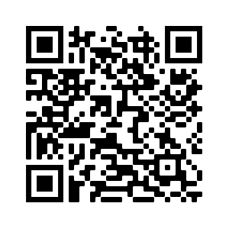
Scan the QR Code to access the Lincoln Library

On your mobile device, scan the QR code above. You will then be connected to the Lincoln Library. Tap on the three lines beside the SEARCH box. Go to the bottom and tap on LOG IN. Enter your school username and password. Tap on SUBMIT. You can now search for books by author, title, subject or keyword. Tap on the magnifying glass . Your selection will appear and there will be an indication whether or not the book is IN or OUT. If you want to take the book out, tap on the HOLD button, and that information will be sent to the library. If you change your mind, tap on the UNHOLD button and your hold will be cancelled. The book will be pulled from the shelf and delivered to you. If the book is OUT, you can still put a hold on it, but it may take some time for you to receive it.

