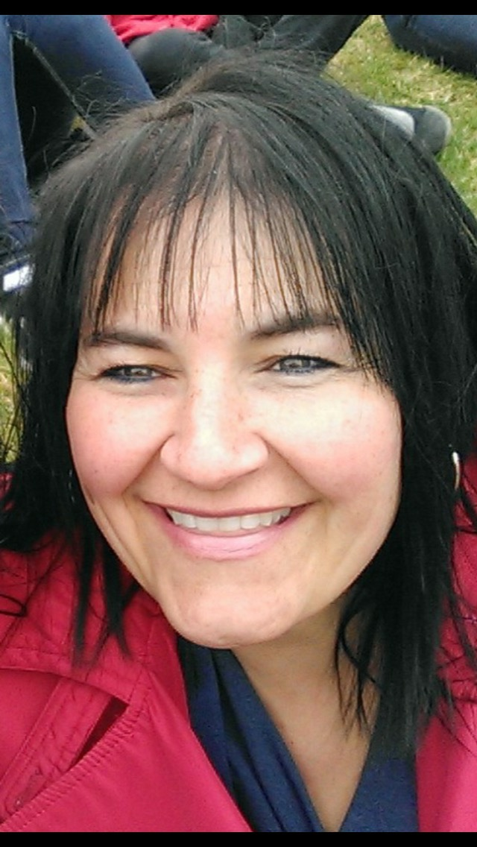
Aaniin! My name is Richelle Scott and my Spirit name is North Star (Giiwedinong Anong). I am of Anishinaabe decent and my ancestors are from St. Peter's Reserve (Selkirk). I have three daughters and I am a Kookoo of a fabulous grandson, named Darius, but I call him Noozhis (it means grandchild).

I am now the Indigenous Early Years Team Leader for the St. James-Assiniboia School Division. I have been teaching for 24 years in early year’s classrooms. I am a traditional drummer and singer and I lead a traditional life. I attend ceremonies both in Manitoba and Ontario. I am a Mide woman, pipe and water carrier and Sun Dancer. My traditional beliefs guide me on my daily journey when working with Elders, children, parents and colleagues. Because my culture is important to me, I have recently finished my second Post Bacc. on Indigenous Knowledge and I have a Masters in Land-based Education. I recently started a new journey towards my learning my language, Anishinaabemowin.

