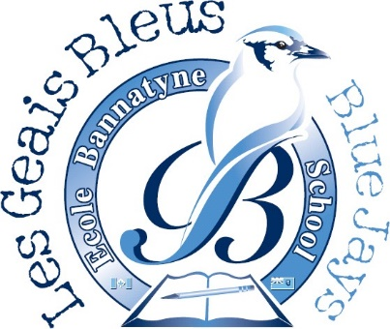
École Bannatyne
Dance-A-Thon
2022-2023

April 13, 2023
Hello families,
We are so excited to be raising funds for our school with a “Dance-A-Thon” on April 28, 2023! Mme Cullen has taught several dances this year and our students are excited to have a period in the day with their grade level to dance in the gym. As you know this is our only fundraiser for the school and we hope to raise approximately $5000.
Our goal is to have fun and exercise in the spirit of fundraising. Students are invited to ask friends/family to donate to help support our school. Please consider donating by EFT sent to: bannatyne.etransfers@sjasd.ca with student name included in the notes or by using SchoolCash Online: Link to School Cash If you wish to make a cash donation, please send the donation to your child’s homeroom teacher before April 27, 2023. Feel free to share the link with family and friends.
This money is used to fund special activities such as plays, cultural activities, special equipment, field trips, etc. We are grateful for any donation as every little bit helps! Thank you in advance for helping the school and for making this event a huge success! If you have any further questions, please contact your child’s homeroom teacher. The class that raises the most funds per capita will win an in-class Movie and Popcorn Party on May 4, 2023.

Merci,
École Bannatyne
______________________________________________________________________________
Cash Donation Submission Form

Student Name: _________________ Teacher’s Name: _________________

Total amount donated: ___________

